# Media-Core

## Introduction

Media Core is a platform to help users communicate to each other by the means of any type of multimedia. The following are the features

## News Feed on Home Page

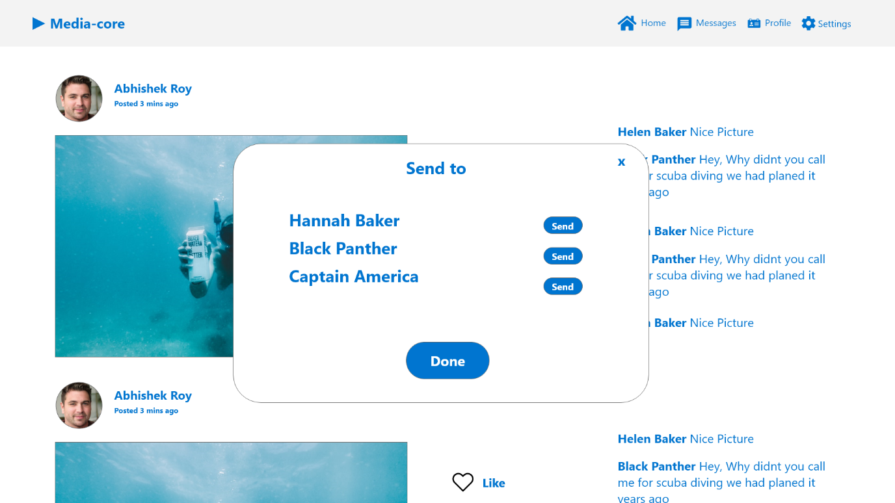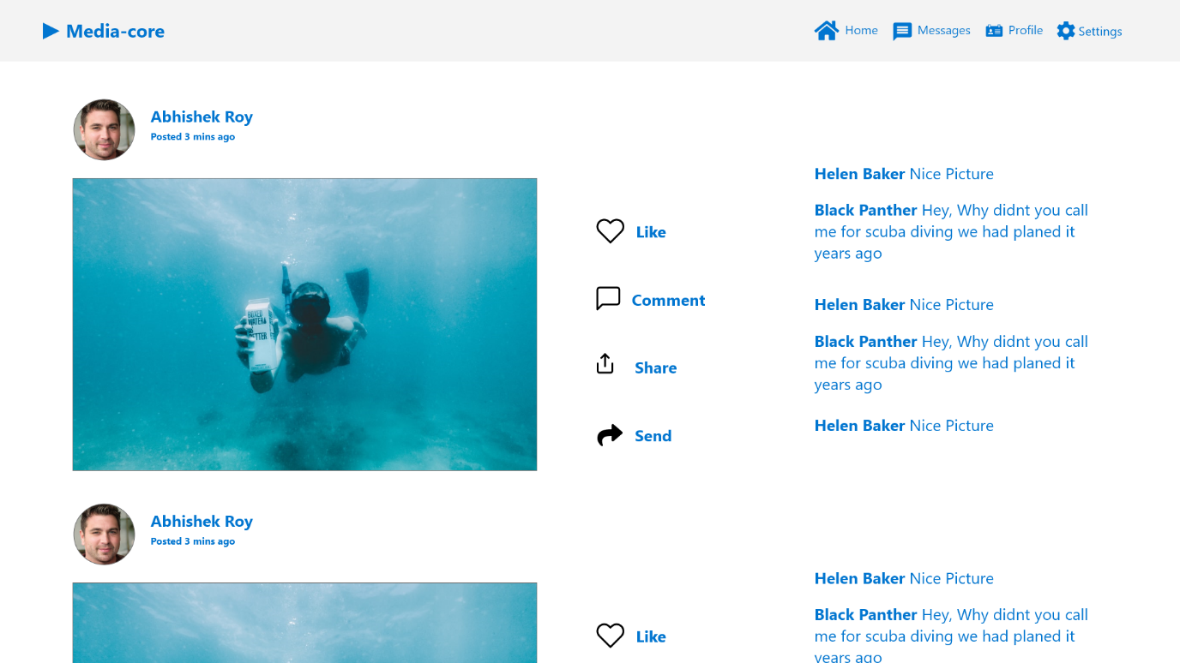All the latest updates from users will be available on the home page. Here one to many interactions are possible. Users can express their emotions by liking and commenting on posts. User can also share the post in their profile or send it their connections for one to one interaction.

## Messages Page

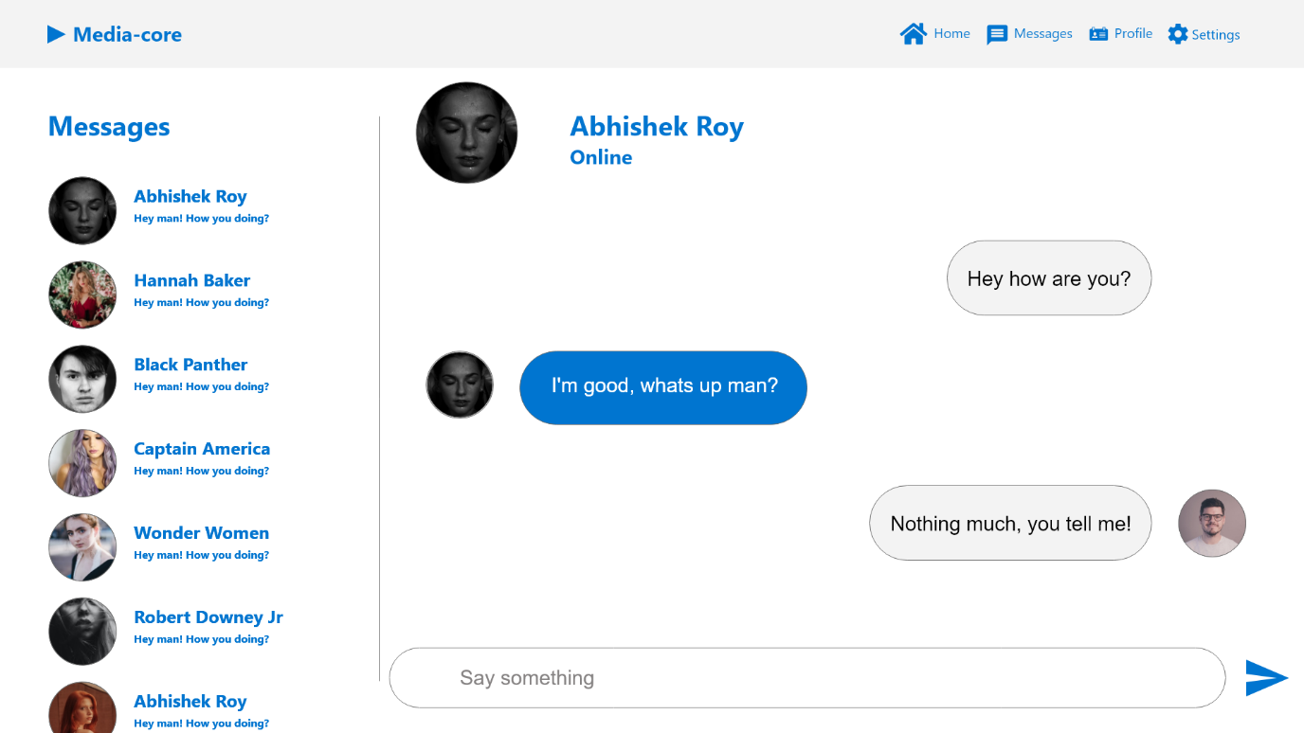User have a separate page for one on one conversations with their connections.

## Profile Page

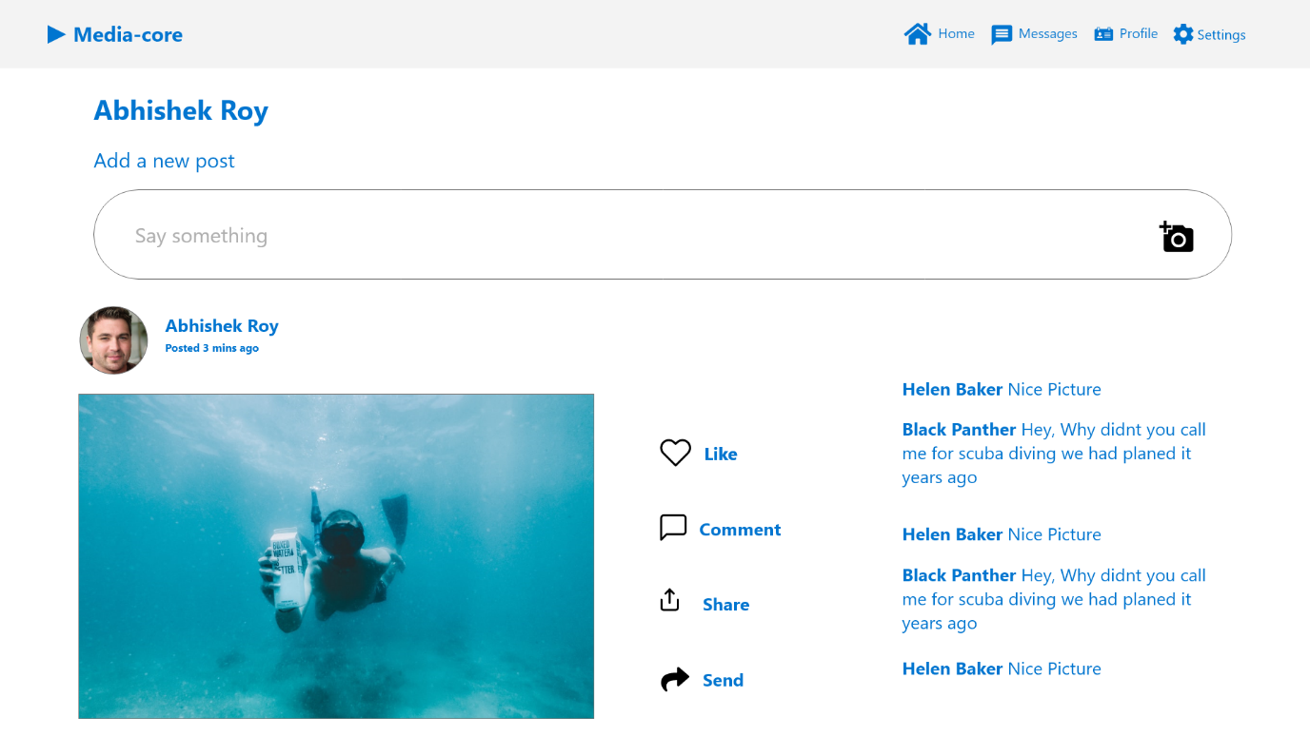This is where users can view their old posts or update a new post.

## Settings Page

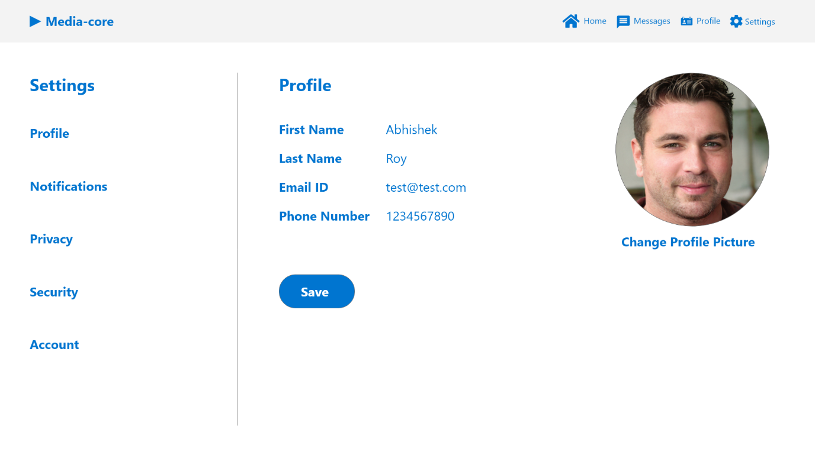Users can update their account settings in this page.

## The navigation and the flow of the web design

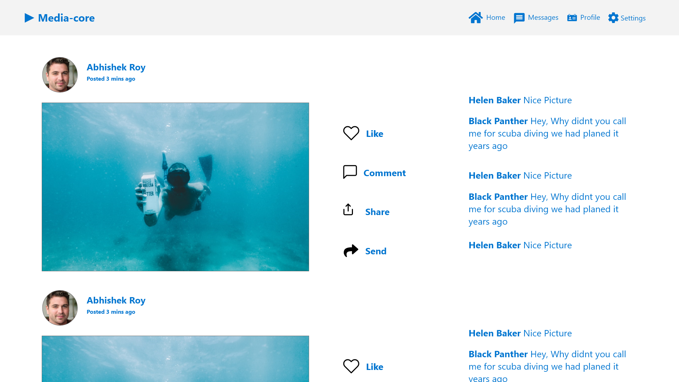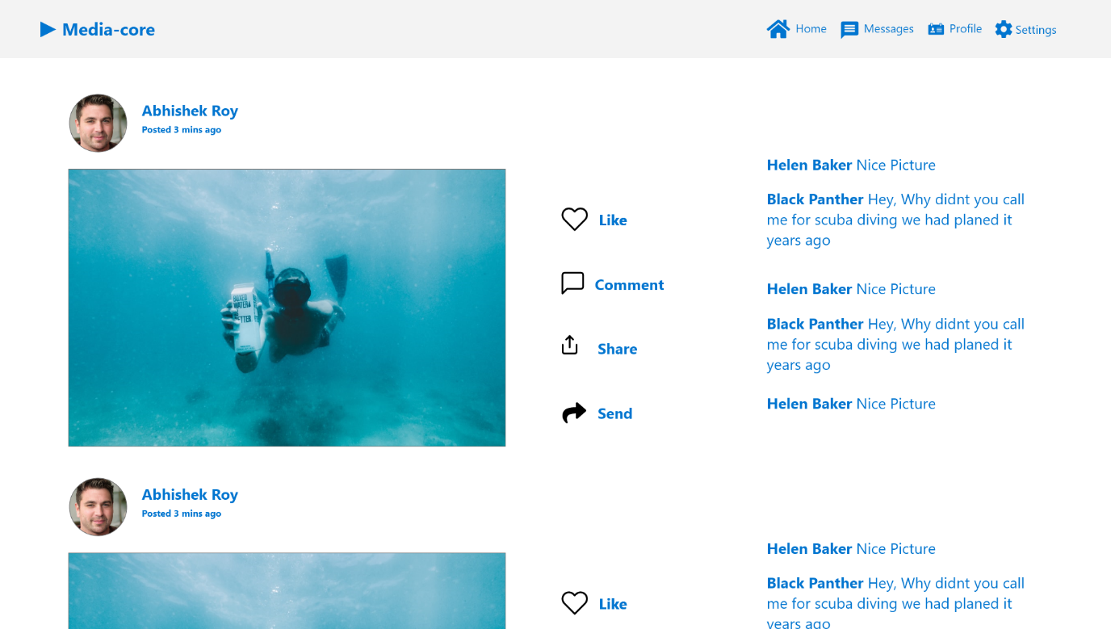Users can jump from one page to other page while staying on any page by using the navigation bar given on the top the page. It is fixed to the top for ease access.

## References

These wireframes were made with the help of Adobe XD using plugins to get icons and pictures.

* <https://www.adobe.com/in/products/xd.html>
* <https://uifaces.co/>
* <https://www.flaticon.com/categories/art-and-design>